SkillSwap Platform – Data Science & Analytics Documentation

1. Introduction
The Data Science module analyzes user skill data from the SkillSwap platform to generate useful insights. The purpose of this module is to understand skill demand, skill supply, skill gaps, and user matching patterns.
This analysis helps improve the skill exchange process by identifying which skills are highly requested and which skills are less available.

2. Objectives
The main objectives of this module are:
To load and preprocess user data
To analyze skill demand and supply
To identify skill gaps
To analyze request status
To implement AI-based skill matching
To visualize the results using graphs

3. Tools and Technologies Used
Python
Jupyter Notebook
Pandas
Matplotlib
Scikit-learn
TF-IDF Vectorizer
Cosine Similarity

4. Dataset Description
The analysis uses three datasets:
Users Dataset
Contains user information including:
User ID
Name
Skills Offered
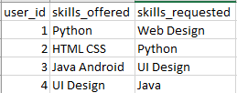
Skills Requested
●User Dataset

Requests Dataset
Contains skill exchange request details:
Request ID
Sender ID
Receiver ID
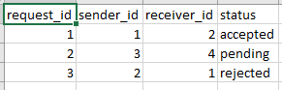
Status
●Request Dataset

Feedback Dataset
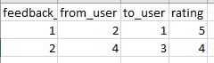
Contains user feedback information.
●Feedback Dataset
5. Data Preprocessing
The data preprocessing steps included:
Converting skills into lowercase
Splitting multiple skills into list format
Removing extra spaces
Preparing the data for analysis
This step ensures consistency and accuracy in analysis.

6. Skill Demand vs Supply Analysis
Skill demand and supply were calculated using Counter function.
Skills offered by users represent supply
Skills requested by users represent demand
7. Skill Demand vs Supply Visualization
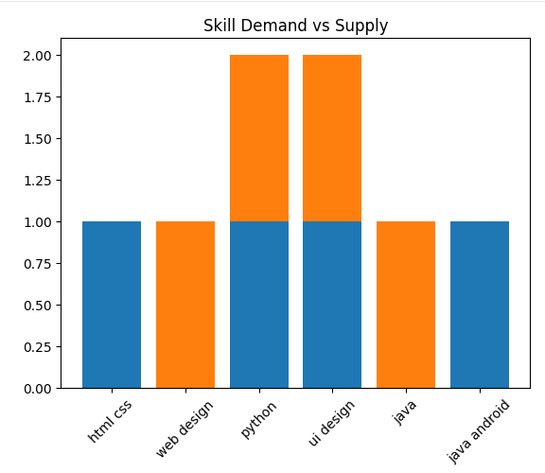
A bar graph was created to visualize skill demand and supply.
●Figure: Skill Demand vs Supply Graph
This graph shows comparison between skills offered and skills requested.
8. Skill Gap Analysis
Skill gap analysis identifies skills that have:
High demand
Low supply
Skill gap is calculated using:
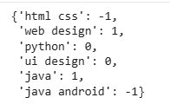
Skill Gap = Requested – Offered
Positive values indicate high demand and low supply.

9. Request Status Analysis
Request status analysis was performed to understand how many requests were:
Accepted
Pending
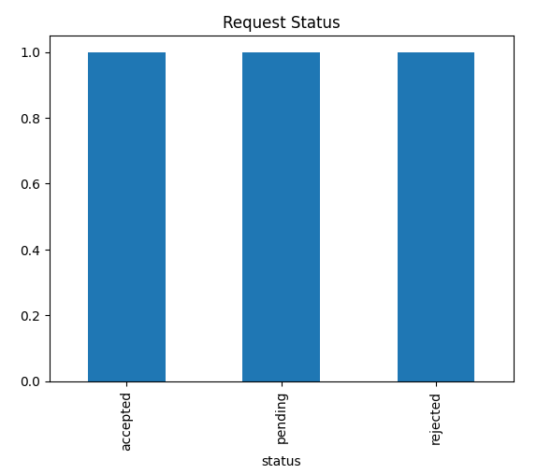
Rejected
●Figure: Request Status Distribution
10. AI-Based Skill Matching
AI-based skill matching was implemented using:
TF-IDF Vectorizer
Cosine Similarity
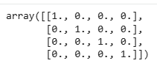
This method calculates similarity between users based on skills.

Higher similarity score indicates better skill match between users.

11. Results and Insights
The analysis provided the following insights:
Identified most demanded skills
Identified most offered skills
Identified skill gaps
Analyzed request status
Implemented skill matching logic

12. Conclusion
The Data Science module successfully analyzed user skill data and generated useful insights.
This analysis helps improve:
Skill matching
Platform effectiveness
User experience

